Les11 - ALTER

From chapter 2 part 2



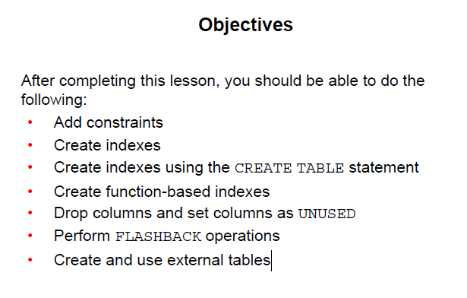

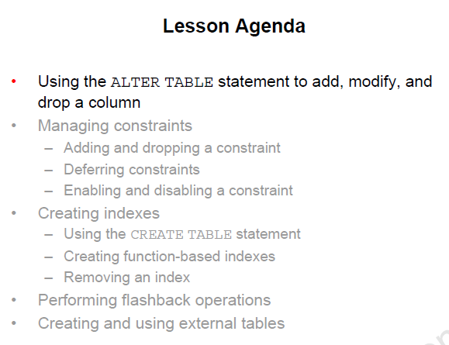

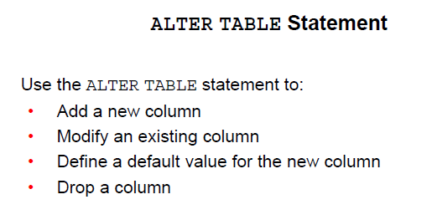

You may need to make changes to a table you created.

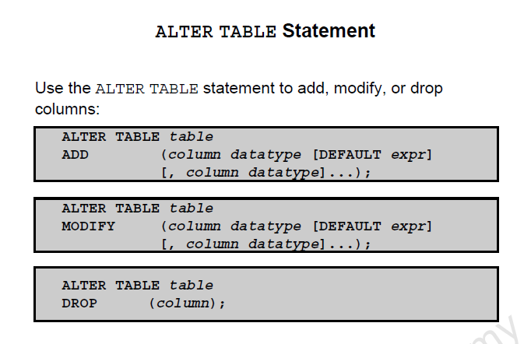

SYNTAX

ALTER

TABLE - name of the table

ADD – MODIFY – DROP is the type of modification

COLUMN -- name of column effected

DATATYPE -- datatype and length of the column

DEFAULT expr – specifies he default value for a column

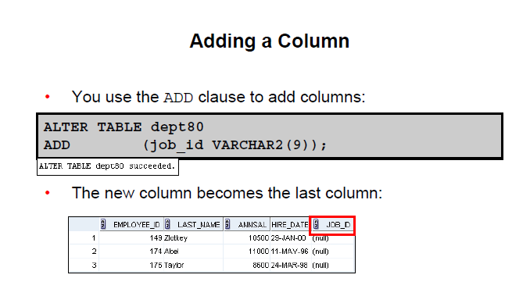

You can add or modify a column

You cannot determine the order of the columns

In the above the column added is the last column

If table has row of values, then the column is either null or the default

If column is NOT NULL, then it needs a default value to start with

If table is empty you can add a NOT NULL without the need for a default value.

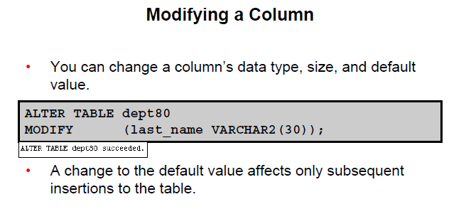

GUIDELINES:

Increase width or precision of numeric columns

Increase width of character columns

You can decrease width if

- The column has only NULL values

- The table has no rows

- The decrease is not less than the values in the column

You can change the data type if null

- except CHAR to VARCHAR is allowed

A change to the default only effects all late inserts

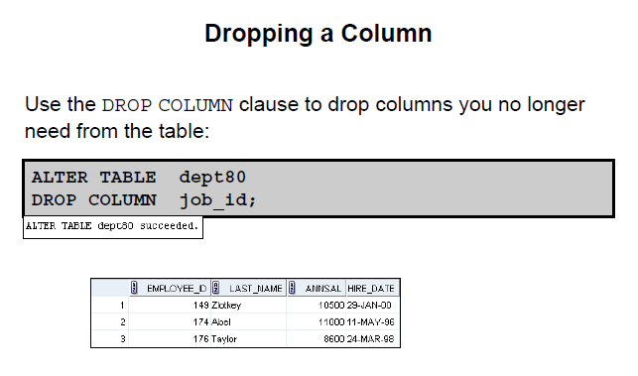

Only 1 column dropped at a time

The column can or cannot have data in it

After the alter there must be at least 1 column left in the table

Columns that are part of a constraint cannot be dropped

Set UNUSED option

Marks 1 or more columns as unused.

Dropping may be slow if there is a lot of data to drop

My be better to mark as unused and drop later when fewer users on system

SELECT * will not show the data even though it is still there

DESCRIBE will not show the columns

You can DROP UNUSED COLUMN to remove a column marked as unused.

Sample:

ALTER TABLE DEPARTMENTS

SET UNUSED (PHONE); 🡸 message results in ALTER TABLE succeeded

This removed access to the data

ALTER TABLE DEPARTMENTS

DROP UNUSED COLUMNS; 🡸 message results in ALTER TABLE succeeded

This removes the data and frees up space

ALTER TABLE – ADD CONSTRAINTS

ADD constraints

DROP constraints

-- Not modify THE STRUCTURE

ENABLE

DISABLE

ADD NOT NULL

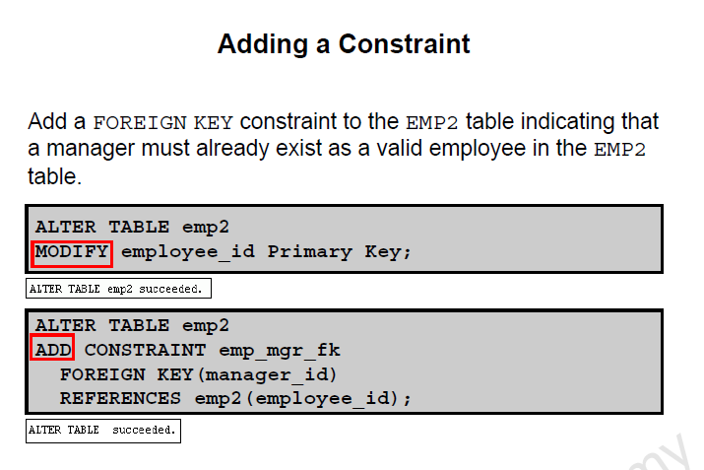

ON DELETE CASCADE

Delete child rows when a parent key is deleted

ALTER TABLE EMPLOYEES

ADD CONSTRAINT em_dt_fk

FOREIGN KEY (department_id)

REFERENCES departments (department_id

ON DELETE CASCADE

Allow parent key data that is referenced in the child table to be deleted but nor updated

When parent row is deleted, all child rows that reference that parent key is also deleted.

DEFERRING CONSTRAINTS

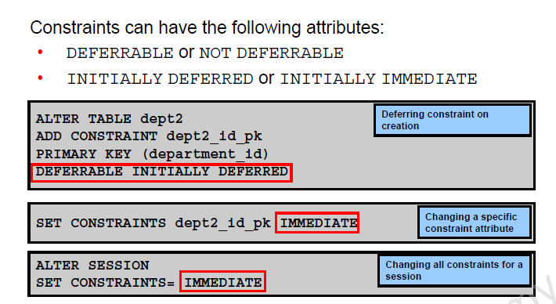

This is a way of deferring the checking of constraints until the end of a transaction.

If at a commit the transaction is not correct and a constraint is violated the commit causes the transaction to roll back.

EXAMPLE of usage:

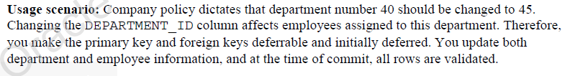

Differences

Initially Deferred – Initially Immediate

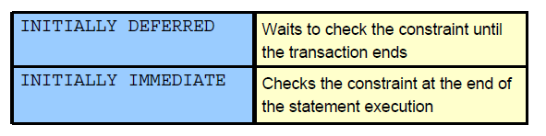

Create a table

CREATE TABLE EMP_NEW_SAL

(SALARY NUMBER

CONSTRAINT sal_ck

CHECK (salary > 100

DEFERRABLE INITIALLY IMMEDIATE 🡸 means will check immediately

BONUS NUMBER

CONSTRAINT bonus_ck

CHECK (bonus > 0 )

DEFERRABLE INITIALLY IMMEDIATE

);

ERROR: There is an immediate constraint on SALARY and 90 is a value too small

Do an insert.

INSERT INTO emp_new_sal

VALUES ( 90 , 5 );

The BONUS is not verified at this time as it is deferred. Waits fo a COMMIT or until set the state back to IMMEDIATE

More Examples:

Example 2:

INSERT INTO emp_new_sal VALUES (100, -1);

Successfully insert the row.

COMMIT:

Causes an error as a constraint on bonus was violated. The transaction is rolled back.

Example 3:

SET CONSTRAINTS ALL DEFERRED;

Sets all constraints that can be deferred to that status.

Reissue inset

INSERT INTO emp_new_sal VALUES ( 90 , 5 );

Everything succeeds.

At COMMIT, both constraints ar violated

Example 4:

Change status from deferred to immediate.

SET CONSTRAINTS ALL IMMEDIATE

NOTE:

If you create a table with no deferred aspects, then the constraint is checked immediately.

You cannot set a constraint to DEFERRED that is not deferrable.

SET CONSTAINT newemp_det_pk DEFERRED

Dropping Constraint

2-18

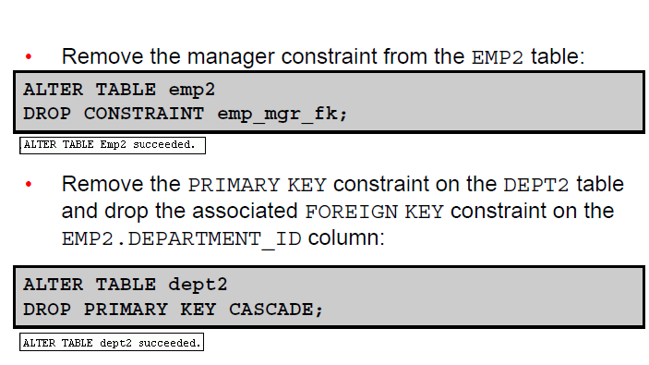

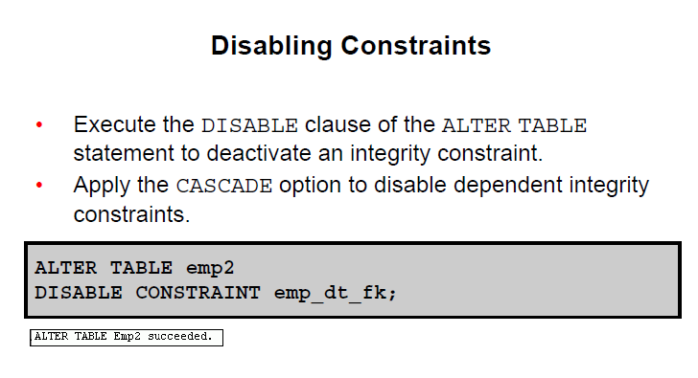

OR

ALTER TABLE EMP2

DISABLE CONSTRAINT emp_dt_fk CASCADE

Disable is available on the CREATE table as well

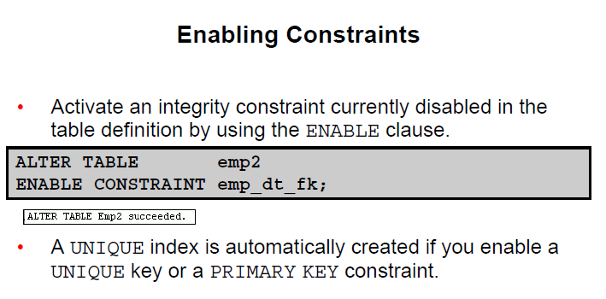

If you enable a constraint applies to all the data in the table

If previously disable with a cascade it does NOT enable the foreign keys that are dependent on the PK

Differences

INITIALLY DEFERRED – INITIALLY IMMEDIATE